In the Sales order form, LOV is appearing like follow:

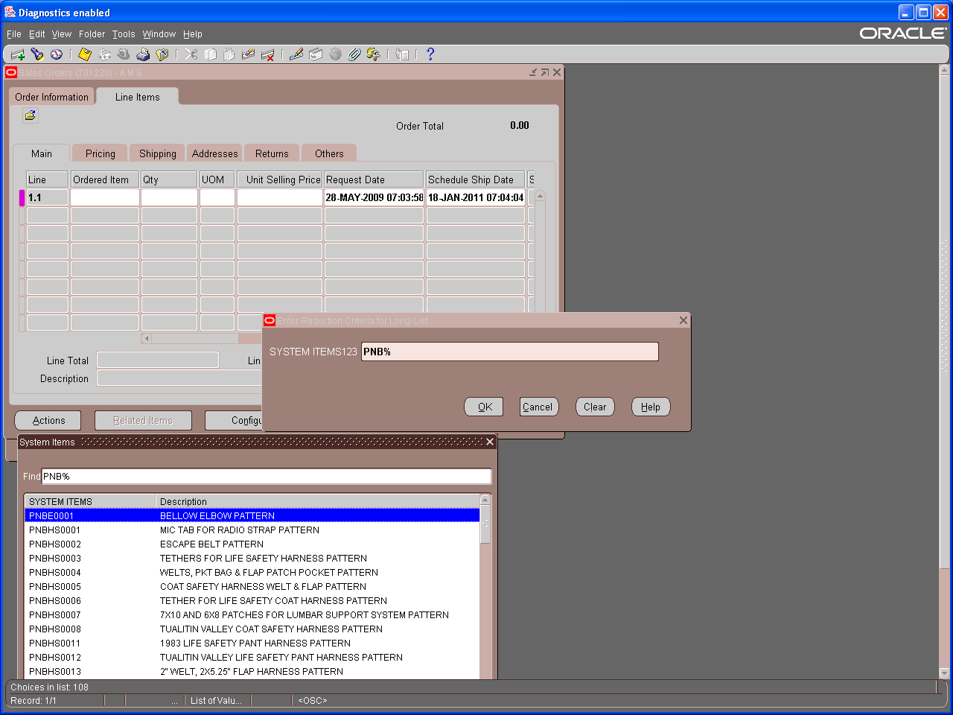

In this form, when I see SYSTEM ITEMS prompt in LOV, I immediately go to System Items KFF and changed its windows prompt to “SYSTEM ITEMS123”. Compiled it. , which is appearing now in above screen shot.

This clearly indicates that Ordered Item is using KFF as LOV.

But when I checked the value set attached to this KFF segment, it is custom one with NONE validation type.

I checked with other instances, they are using different value sets. Ex: one is using “40Char” value set.

Now question is: For NONE type of Value set, where the values are coming from in the front end?

See below screen shot for KFF definition.
