Navigation: Orders. Returns -> Sales Orders

- Enter Customer and Order Type. The other fields may default values. If “Ship To Location”, “Bill To Location” and “Price List” are not defaulted, pick those values from “LOV”

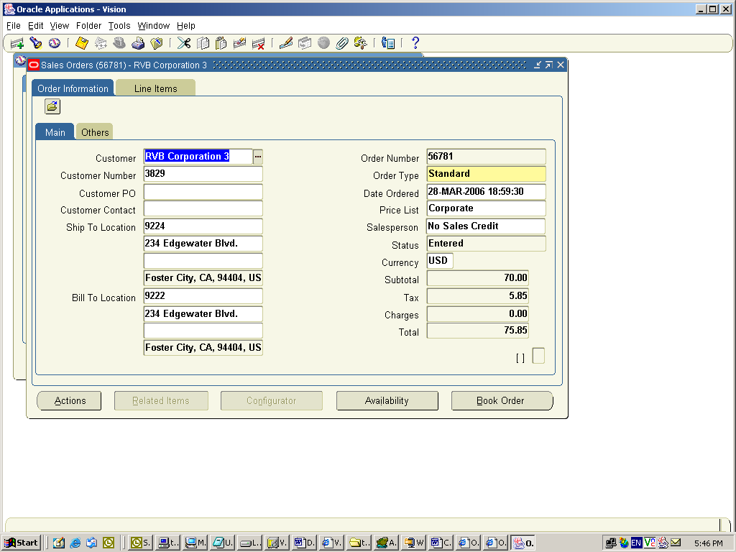

- All the fields should default in Others tab. If Payment Terms or Warehouse is not defaulted, choose values from LOV. Warehouse parameter stores the warehouse from which the order will be shipped

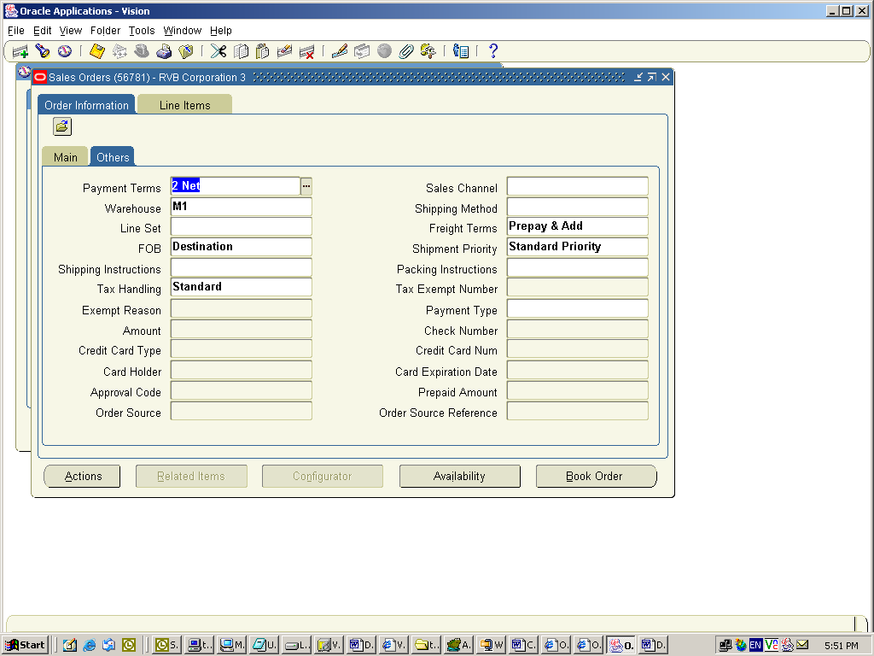

- Enter “Ordered Item”, “Qty”, “UOM”.

Note: The item should already be setup in Inventory. Please refer to Item Setup for the item setup information. The item price should exist in the price list specified at the order header level. Please refer to Price List Setup section for price list setup.

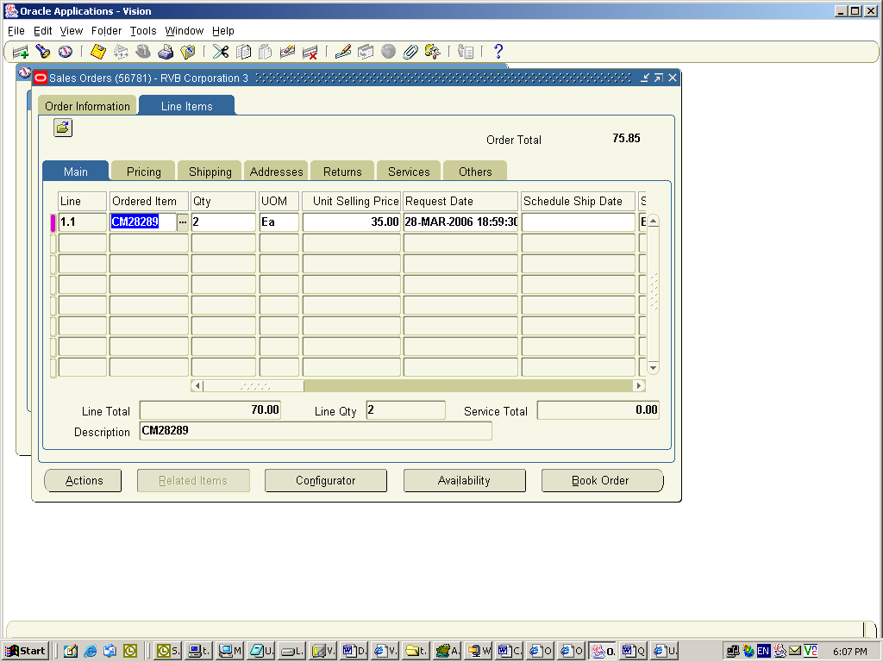

Book Sales Order

Book the order by clicking on “Book Order” button

Pick Releasing a Sales Order:

Navigation: Shipping -> Release Sales Orders -> Release Sales Orders

- Enter the Order Number that needs to be pick released

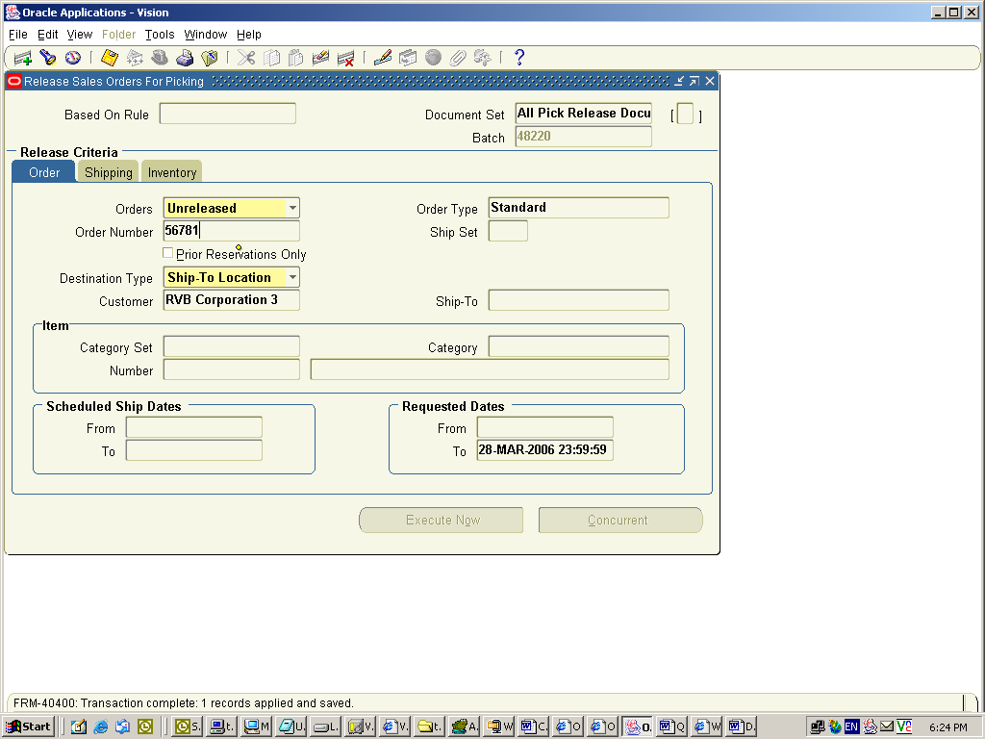

- Specify the warehouse. This should be the same warehouse as specified in the order line.

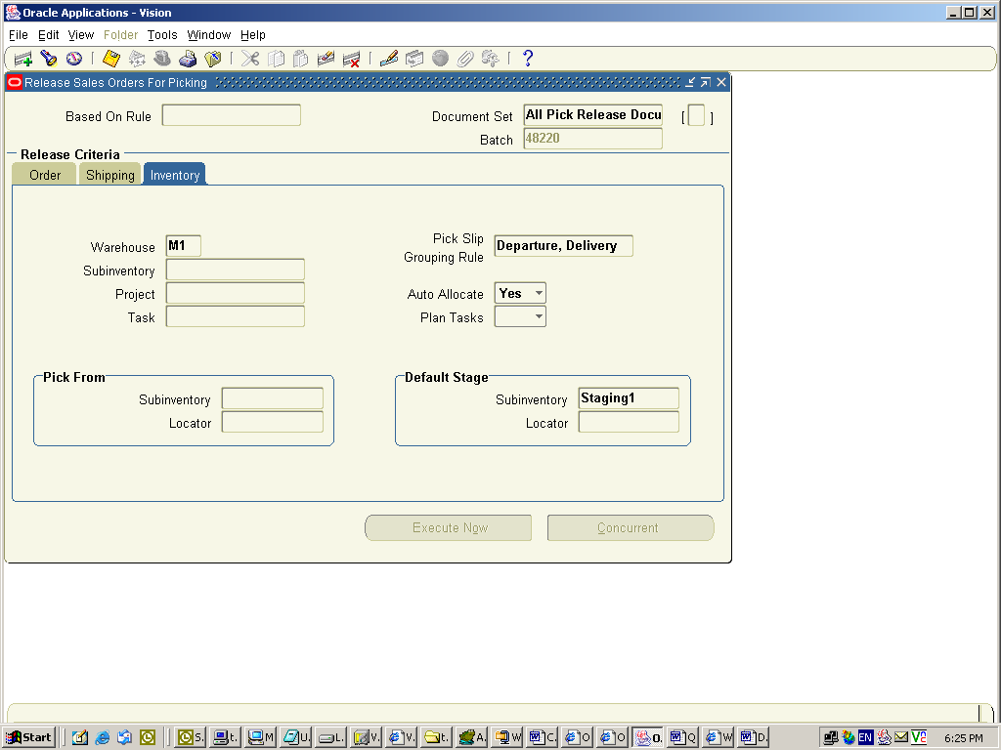

- Click on Concurrent button. This should launch “Pick Release” concurrent program

- Click on “View” and then “Request” menu option. Click on “Find”. It should bring all the concurrent requests submitted by the user. There should be a request called “Pick Slip Report”. Click on “View Output” button to view the orders that are pick released.

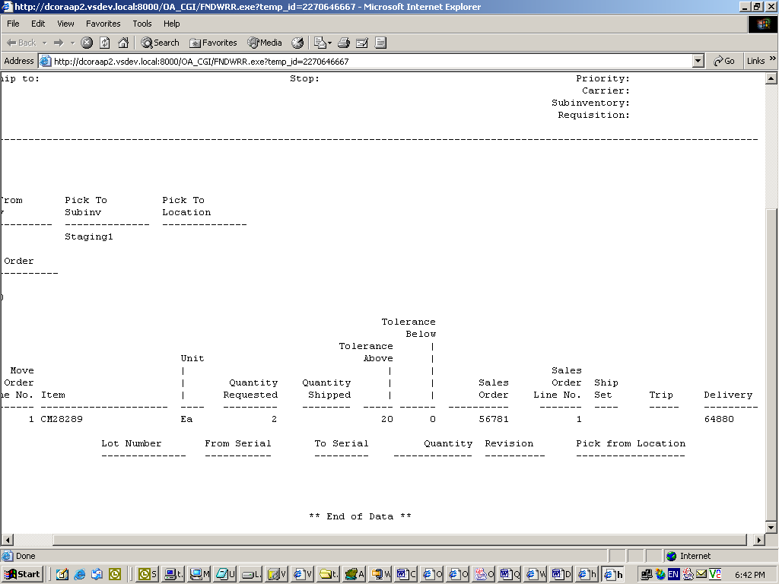

Shipping a Sales Order:

Navigation: Shipping -> Transactions

- Enter the Order Number in “From Order Number” field and click “Find” button

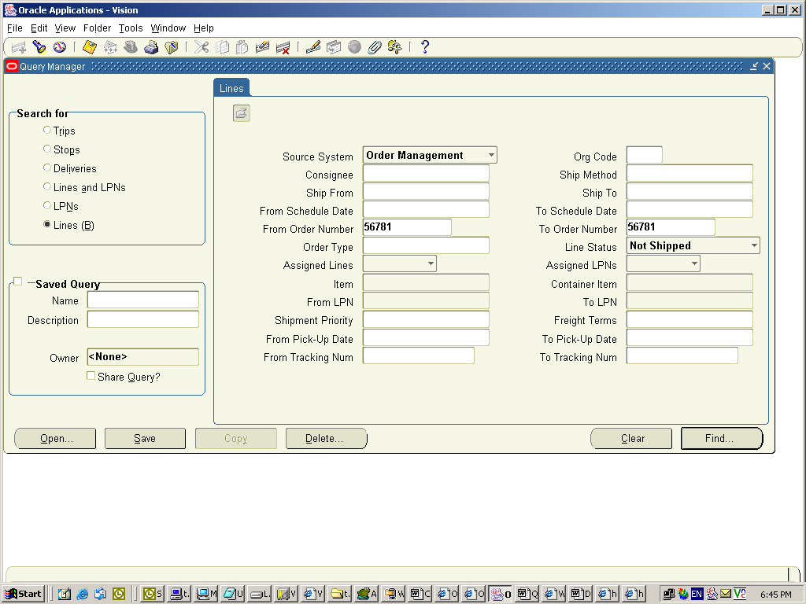

- Click on Details button to enter the ship quantity

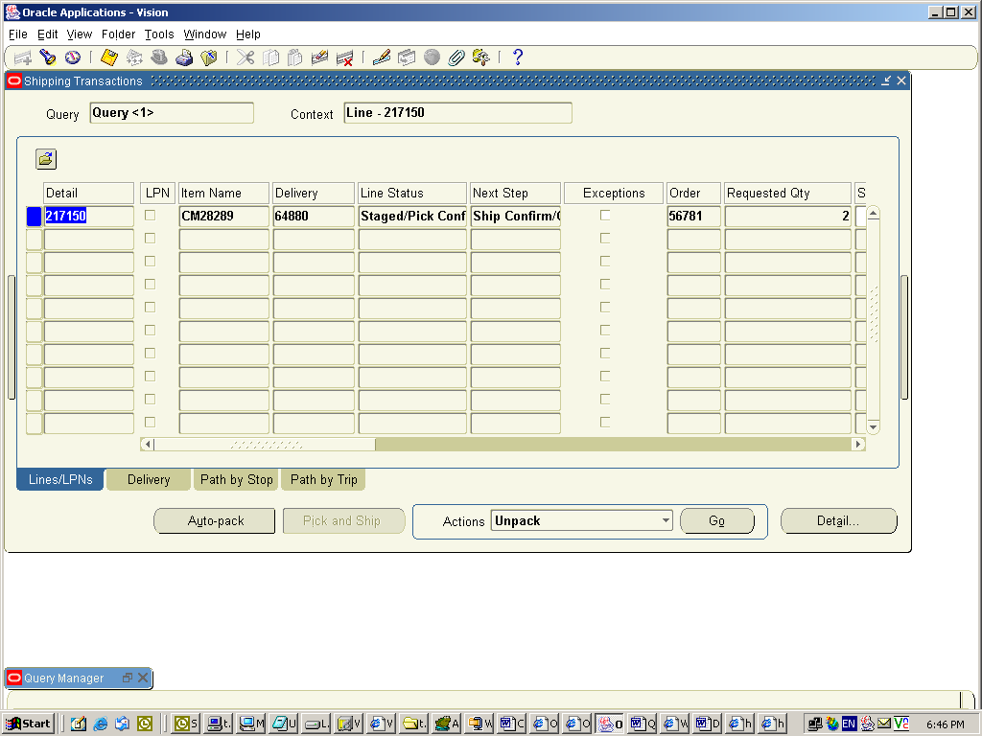

- Enter “Shipped Quantity” and click Done

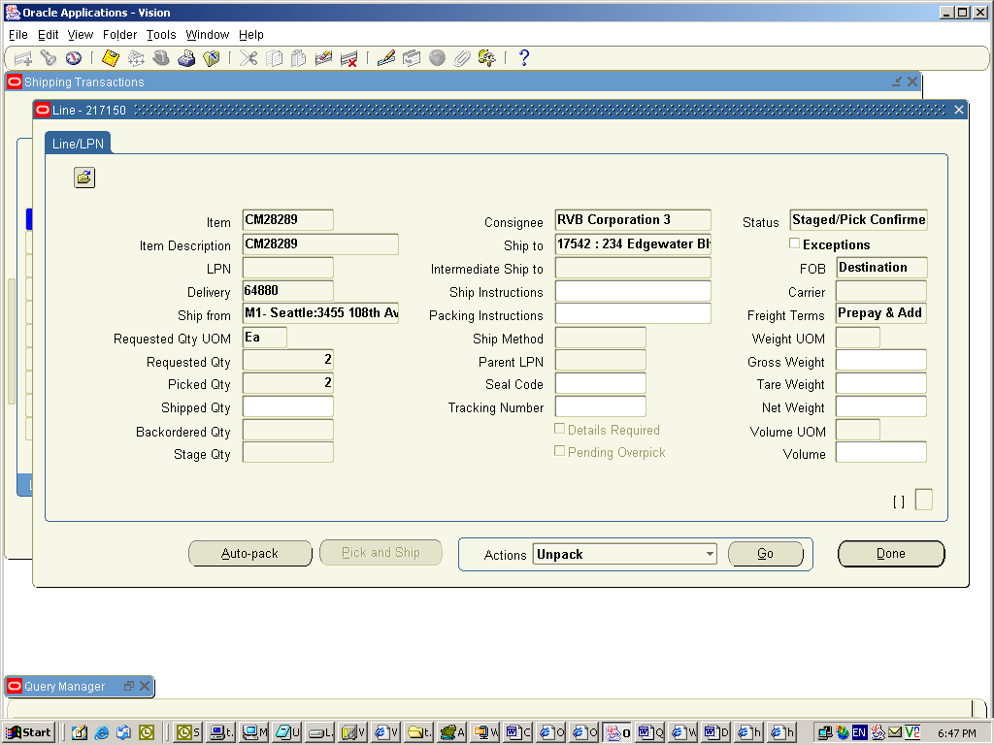

- Click on the “Delivery” tab and select “Ship Confirm” for actions and click “GO” to confirm the shipment

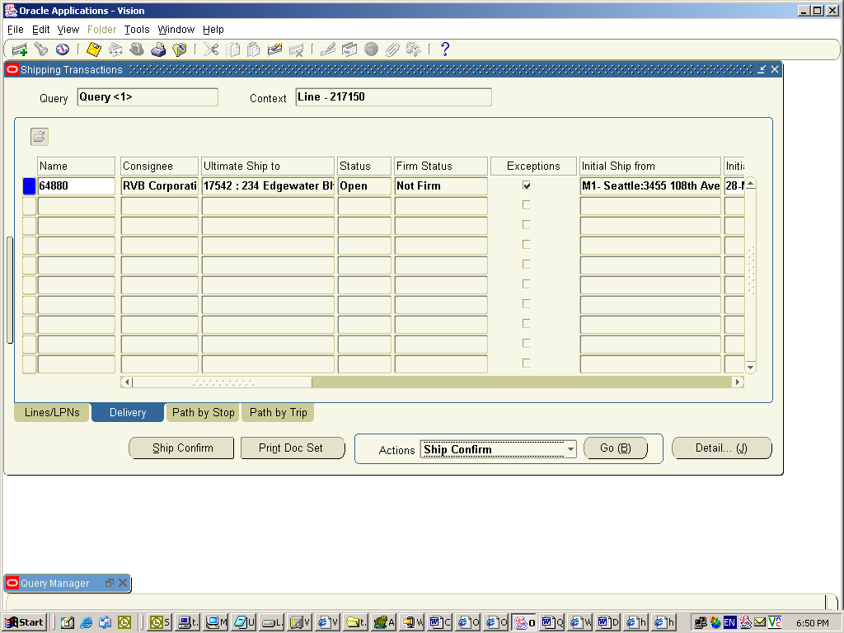

Invoicing a Sales Order:

Navigation: Inventory -> Workflow Background Engine

- Run this concurrent program to interface order to accounts receivables. Select “Yes” for “Process Deferred” and select “Yes” for “Process Timeout” parameters. Click on OK

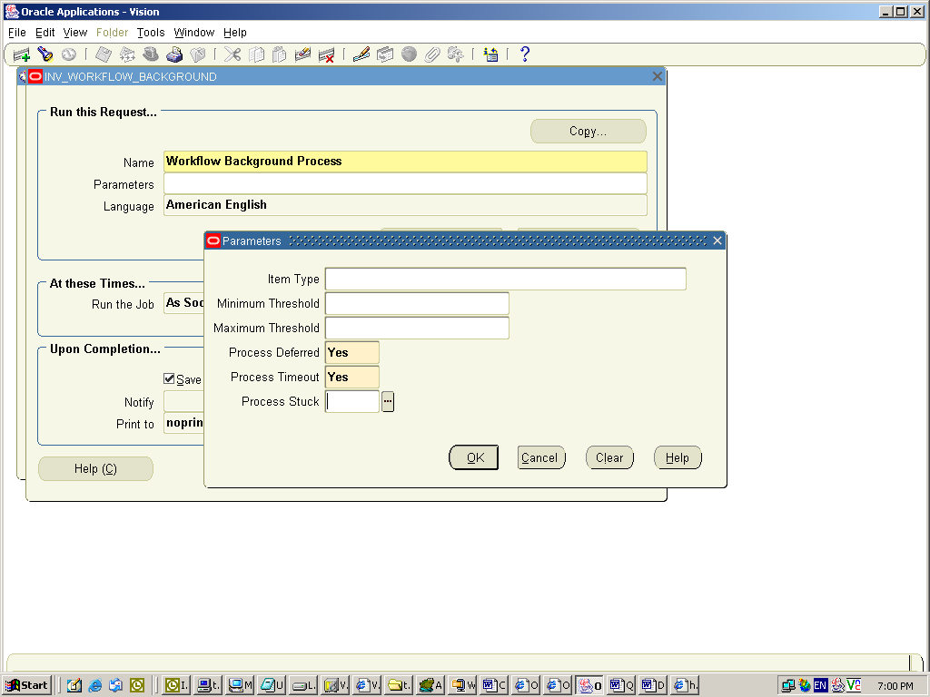

Viewing and Modifying an Invoice:

Navigation: Orders. Returns -> Sales Orders

- Query the order that was invoiced (Press F11, Enter the Order Number and Press Ctrl F11). Right Click on Customer Field and choose “Additional Order Information” -> Invoices/Credit Memos

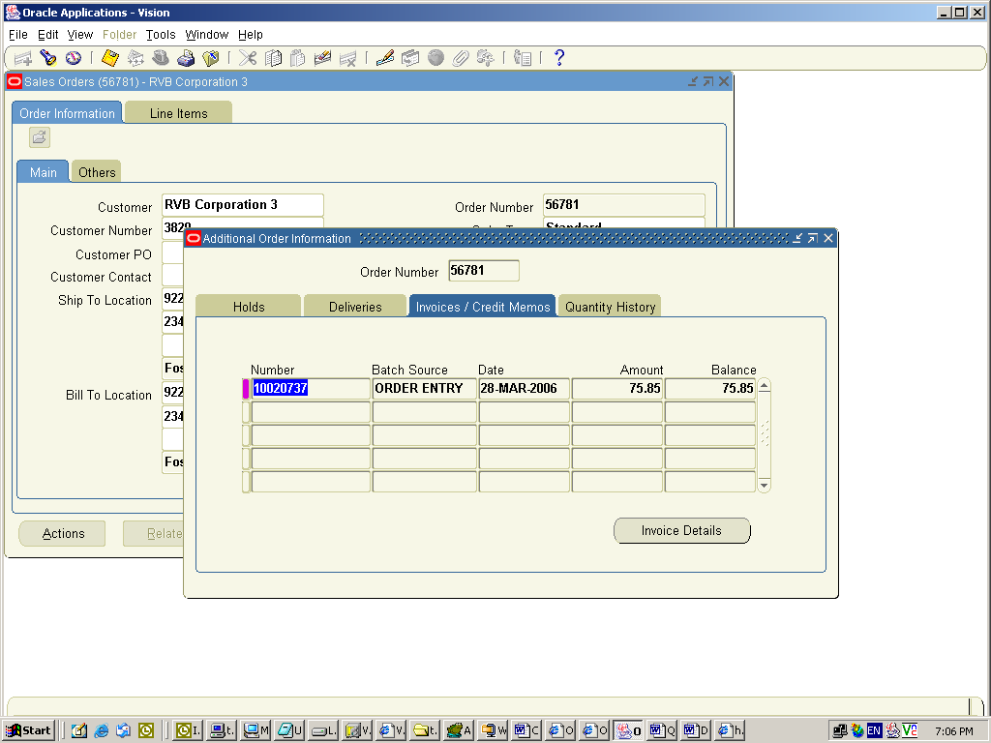

- Note down the invoice number

Navigation: Receivables -> Transactions -> Transactions

- Query the invoice using the invoice number. Order and Invoice can be verified for proper invoicing

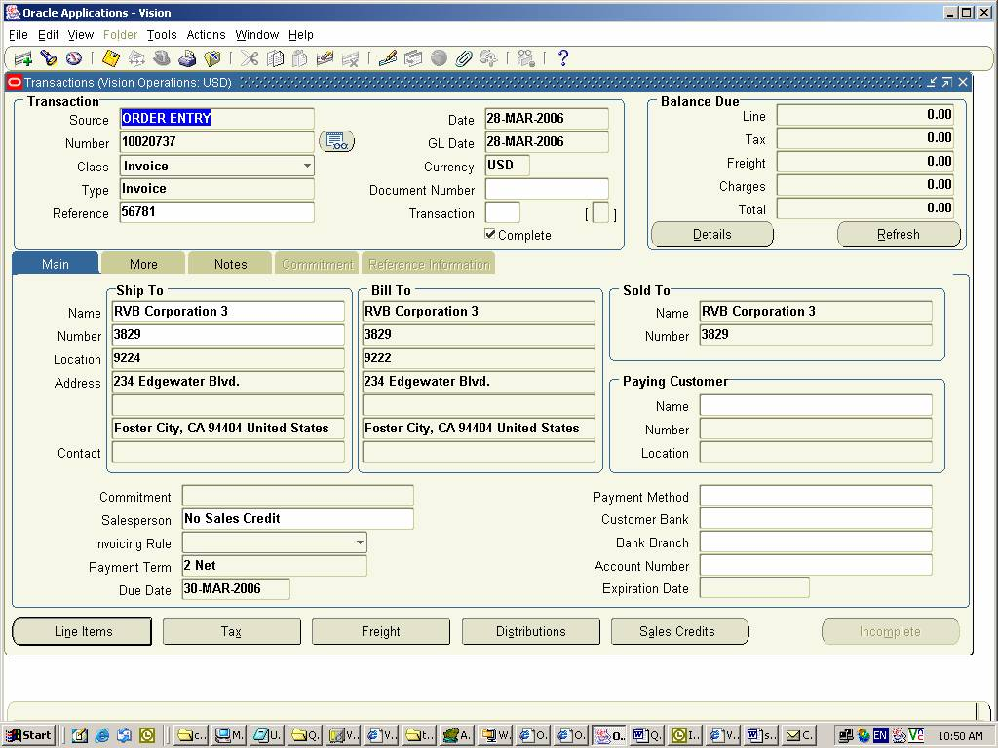

Creating Receipt for the Invoice

Navigation: Receivables -> Receipts -> Receipts

- Enter “Payment Method”, “Receipt Number”, “Receipt Amount” and “Trans Number”. Receipt Amount can be equal to the invoice amount and Trans Number is the invoice number for which the receipt was created.

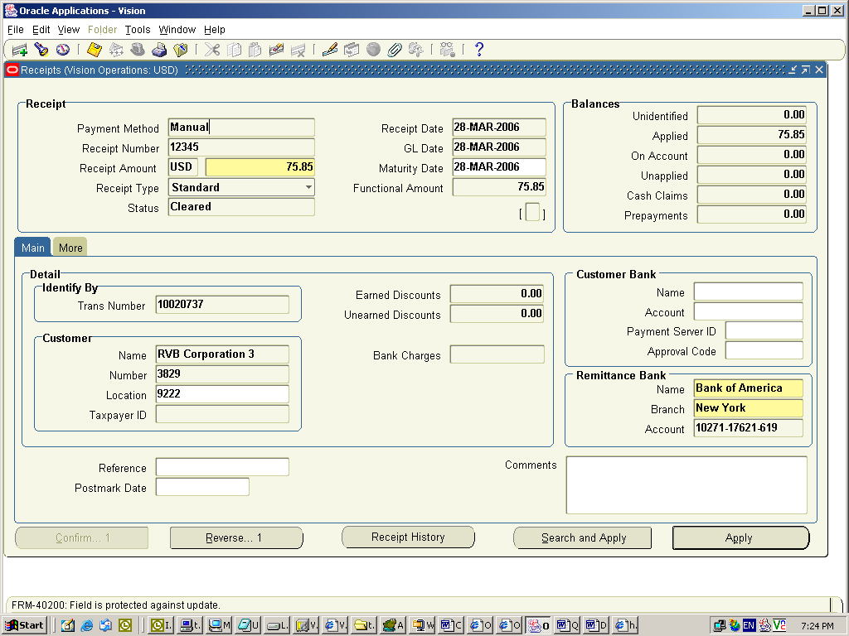

Receivables Transfer to GL

Navigation: Receivables -> Interfaces -> General Ledger

- Run General Ledger Transfer Program to Transfer AR data to GL

